Wicked
Duologue Script
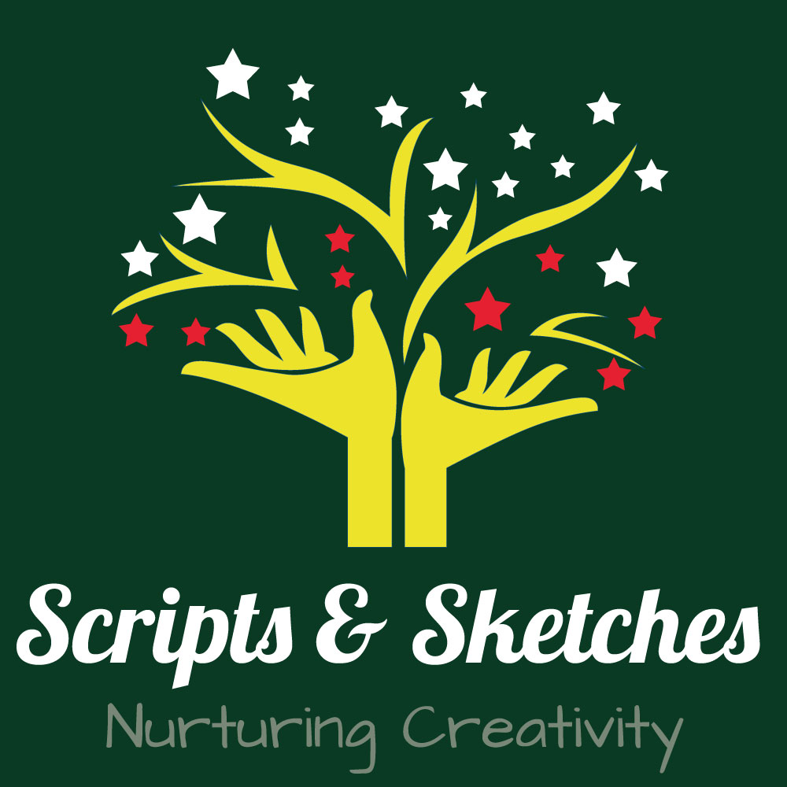
by Stephen Swartz

Published by scriptsandsketches.com
Characters: ELPHANA, GALINDA
__________________________________________________
ELPHABA AND GALINDA’S DORM ROOM.
After the Ozdust Ball, both girls have been up all night, talking.

GALINDA: Your very first party? Ever?

ELPHABA: Do funerals count?

GALINDA: But your very first party! (beat) I know! Let’s each tell the other
something we’ve never told anyone! I’ll go first: Fiyero and I are
going to be married!
ELPHABA: (stunned) He’s asked you already?

GALINDA: Oh, he doesn’t know yet. (beat) Now you tell me a secret.

ELPHABA: Like what?

GALINDA: Like -- (as she retrieves it) Why do you sleep with this funny
little green bottle under your pillow?

ELPHABA: (fiercely, grabbing at it) Give that back!

GALINDA: (holds it out of reach) Come on-- tell.

ELPHABA: It was my mother’s, that’s all. Elphaba rips the bottle away from
Galinda, and shoves it back under her pillow.
GALINDA: Well, that’s not fair, I told you a really good one.

ELPHABA: My father hates me.
Galinda Gasps
ELPHABA: That’s not the secret. The secret is—he has a good reason. It’s my
fault.

GALINDA: What, what is?

ELPHABA: That my sister is... the way she is. You see, when our mother was
carrying Nessa, our father began to worry... that the new baby
might come out—

ELPHABA AND GALINDA (in unison)

--Green.
ELPHABA: He was so worried, he made our mother chew milk flowers, day
and night. Only it made Nessa come too soon... with her little
legs all tangled. And our mother-- never woke up. None of
which would ever have happened... if not for me.

GALINDA: But-- that was the milk flower’s fault, not yours! That may be
your secret, Elphaba. But it doesn’t make it true. (She looks out
the window, sees the sun rising... ) Look-- it’s tomorrow! And
Elphie-- is it all right if I call you Elphie?

ELPHABA: Well, it’s a little perky ...

GALINDA: And you can call me-- Galinda. You see Elphie, now that we’re
friends, I’ve decided to make you my new project.

ELPHABA: You really don’t have to do that.

GALINDA: I know. That’s what makes me so nice!

